1960 Election Kit

1. https://www.youtube.com/watch?v=4oLYqUT24Vk.

Describe the affects that John F. Kennedy had to TV audiences. How did Nixon compare in his use of TV?

2. 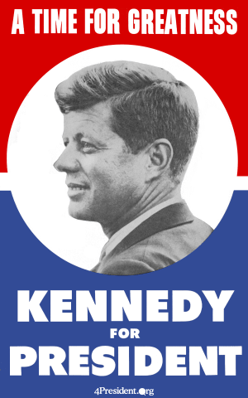
What does this poster convey about the years that Kennedy was wanting to lead the United States through?

3. 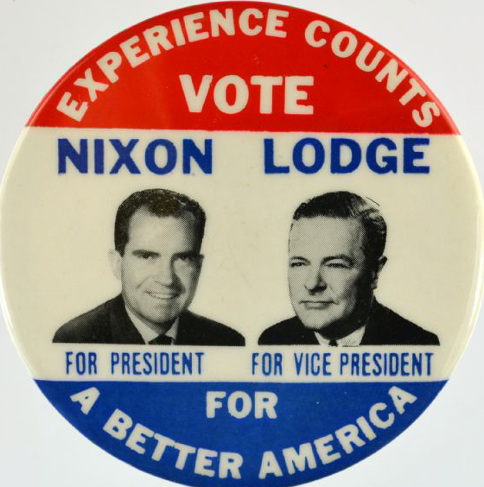
What issue was used by the Republicans in 1960 against Senator Kennedy? Why would they use this issue against the Senator?

4. https://www.youtube.com/watch?v=BqdsLTob8uA.

After watching the video, describe how John F. Kennedy used his charm even before being the presidential candidate. Describe what happened at the 1960 Democratic National Convention between Lyndon Johnson and John F. Kennedy.

5. https://www.youtube.com/watch?v=eYkpPITKR8E.

After watching the video, what issues were brought up in the video and what was Kennedy’s stance? Describe the usefulness this video plays in getting more votes.

6. https://www.youtube.com/watch?v=j3cpQnVvXSs.

Debate the major differences between the two ads of Kennedy and Nixon. Describe which ad would be more effective in a campaign and why.
7. 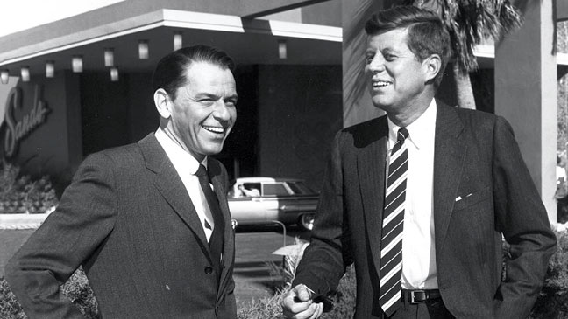
This is a photo of Senator John F. Kennedy and Frank Sinatra. Analyze the importance that this photo has for Kennedy and how it would benefit Kennedy in the 1960 election?

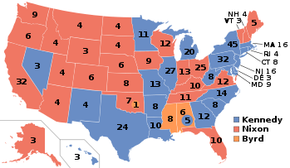
8.
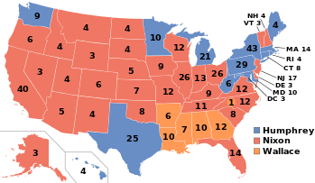
The top map is the election results from the 1960 election. The bottom map is from the 1968 election. Compare and contrast these two maps and predict what changed between these elections.
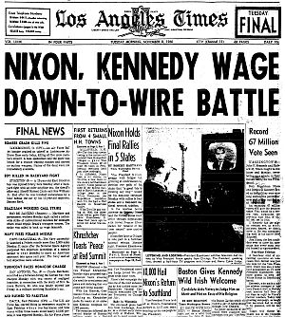
9.
Explain the importance this paper title has tied to the election. What impact would a close election have on the American people?

10. https://www.youtube.com/watch?v=QEG5PCd5L5Q.

After watching the video discuss the importance of Kennedy’s persona, or public image, had on the general public and voters? Do we have a candidate in today’s political atmosphere that displays this public image and if so please compare that candidate to Kennedy?

